**Connected to Postgres DB**

**List of Databases:**

**Command : \l**

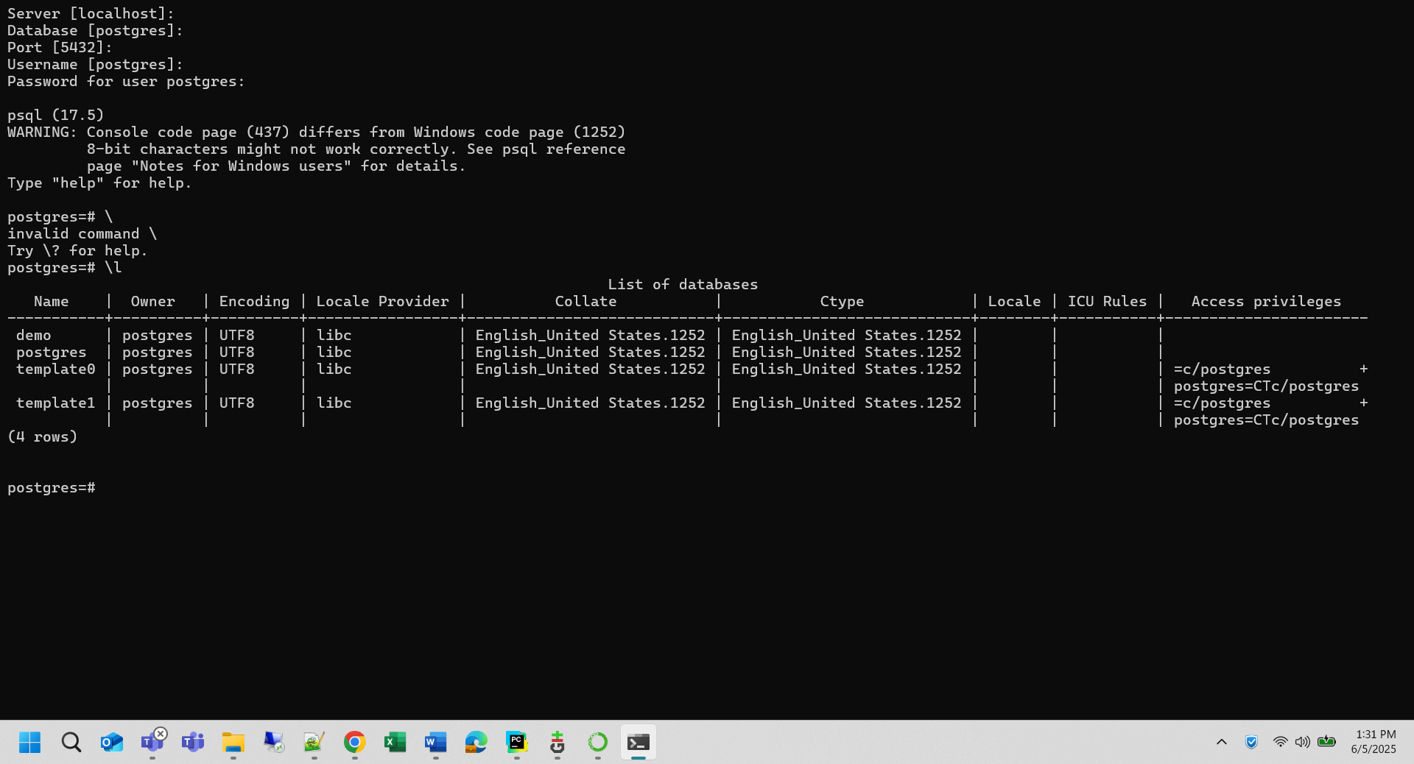

**Creating Database and go to that DB:**

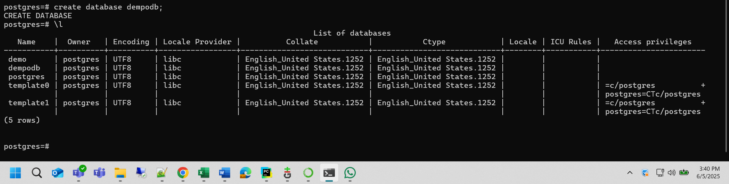

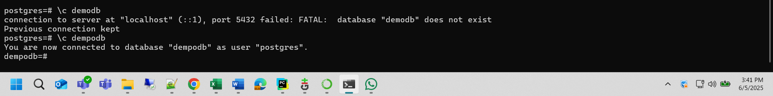

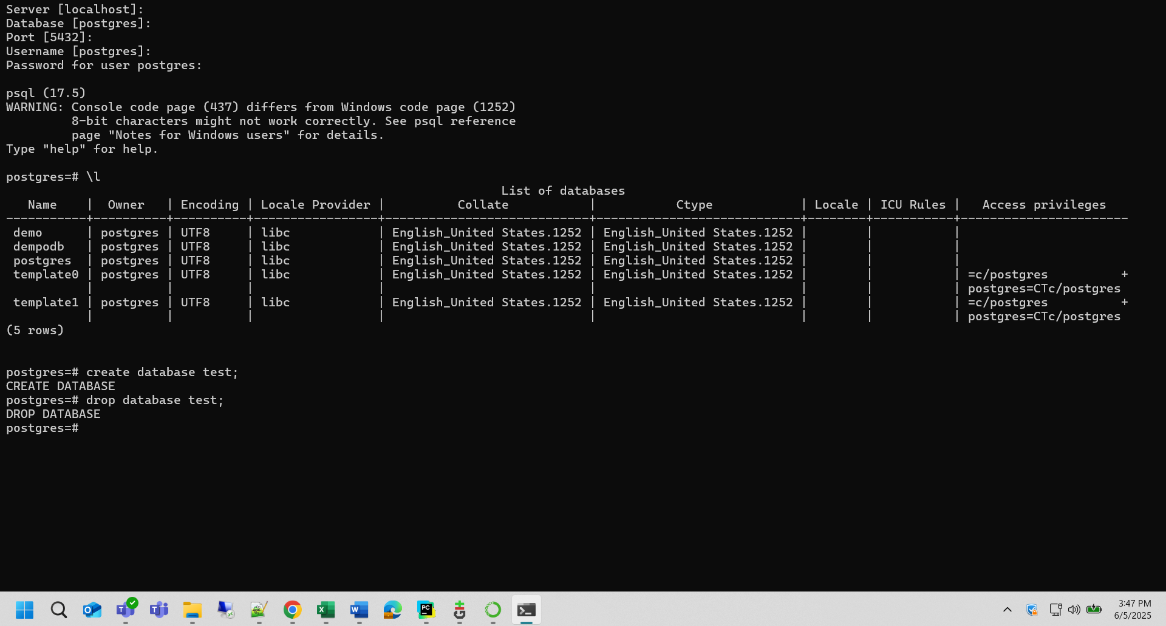

**Create Table and Get data:**

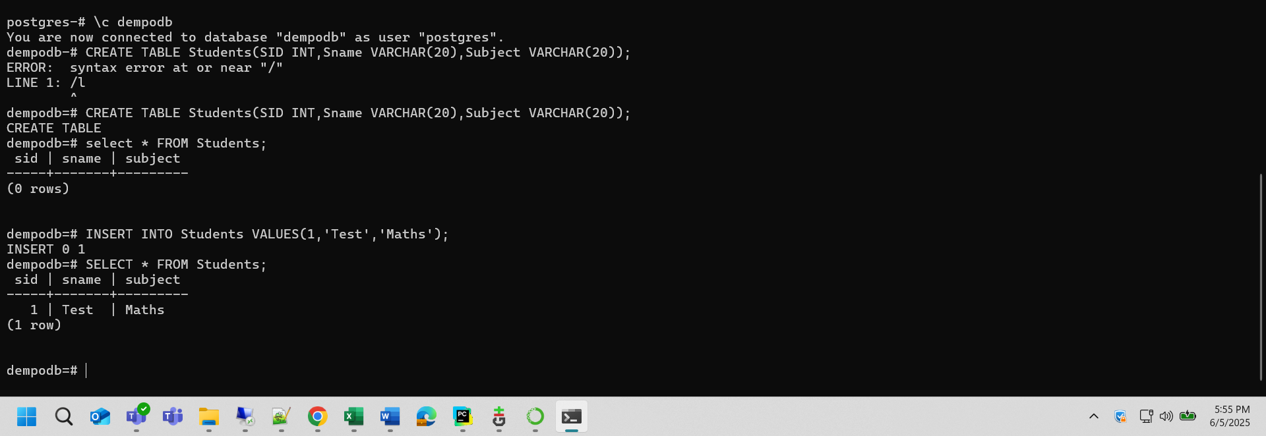

**Get Data and Delete Data:**

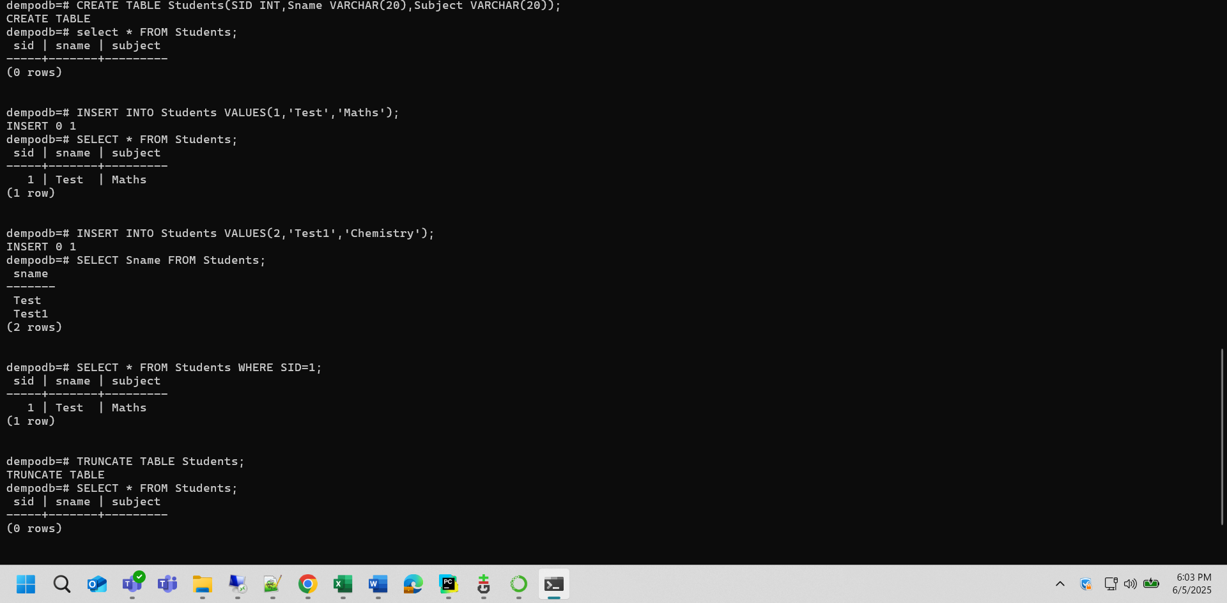

**Create Connection Postgres connection using psycopg2:**

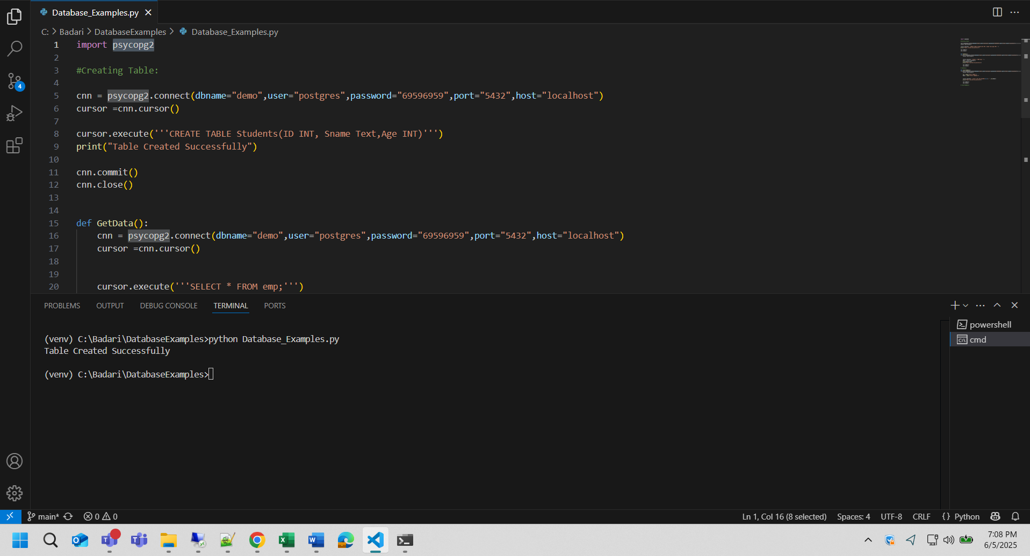

**Insert Data with Python:**

**Get Data from Table using Python:**

